How to use GitHub Desktop

# Downloading GitHub Desktop

1. 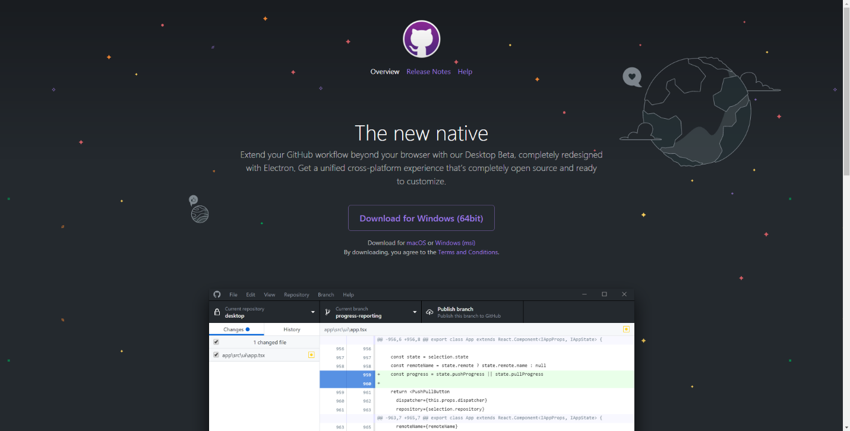Click on this [link](https://desktop.github.com/) and click on “Download for Windows”
2. After the download is complete, open up the GitHubDesktopSetup.exe and proceed through the installation instructions. If you have not already, please create an account from this [link](https://github.com/).

# Repository Cloning

1. 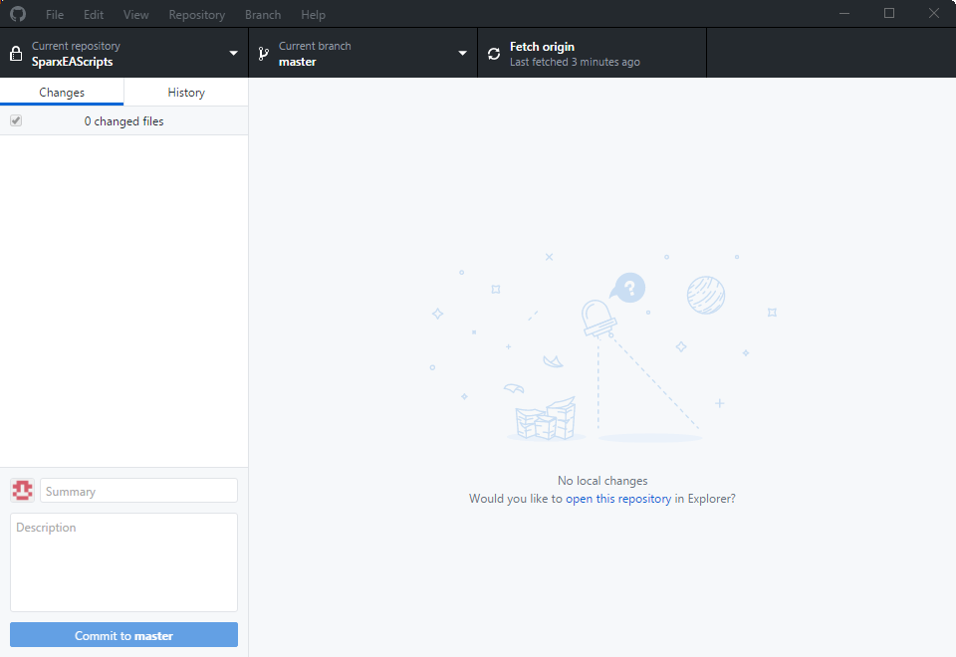When you first open up GitHub Desktop and login with your account information, you will access a screen similar to below.
2. 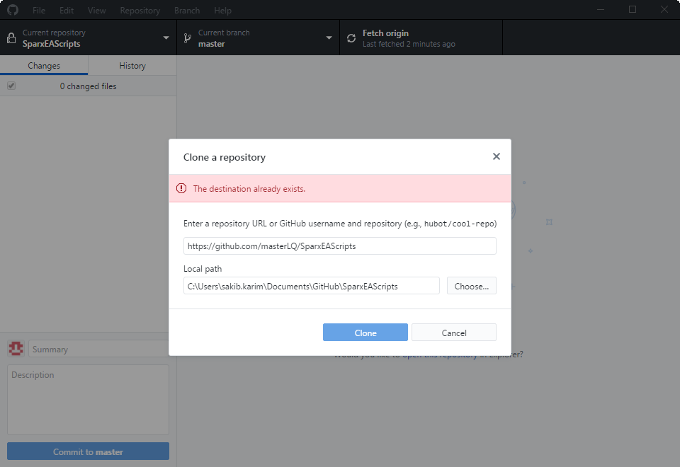After accessing this screen go to File>Clone Repository and copy/paste the repository URL located [here](https://github.com/masterLQ/SparxEAScripts), including your desired file path location.
3. 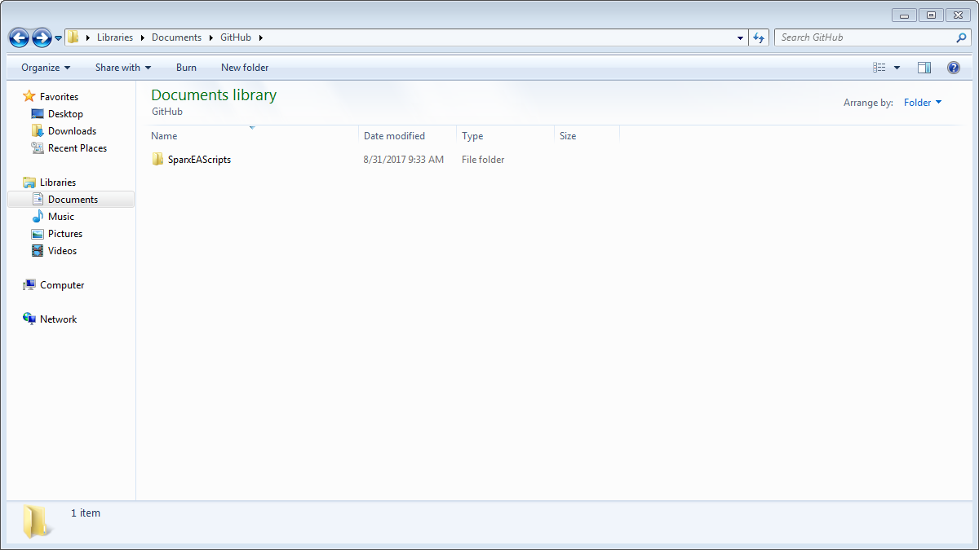After the repository is cloned, head to the local path location to confirm the repository has been cloned.

# Pulling from the Repository (Fetch Origin)

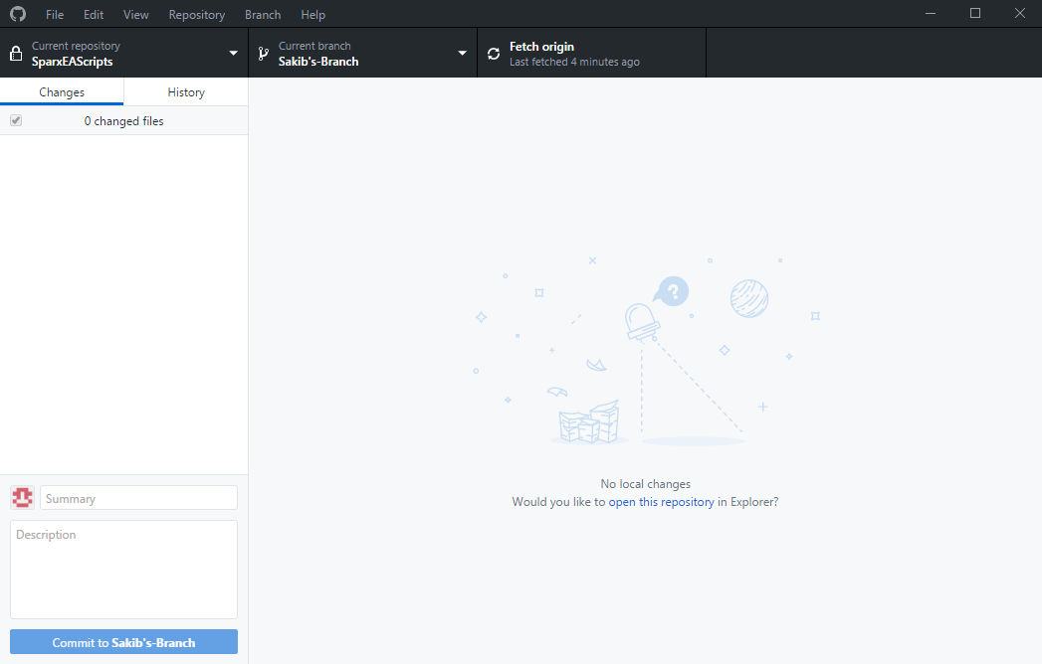Git Pull allows the user to pull the most recent version of the targeted branch of the repository into the GitHub folder. There are multiple methods for pulling from the repository, but the recommended method is “Fetch Origin.”

# Pulling from the Repository (Pull)

Git Pull is also accessed through Repository>Pull, or through the shortcut Ctrl+Shift+P. This performs the same function as “Fetch Origin.”

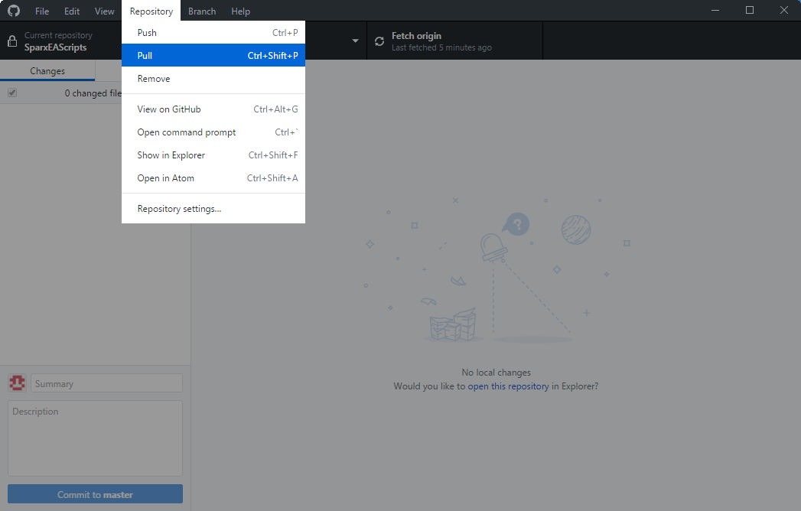

# Committing and Pushing to the Repository

1. 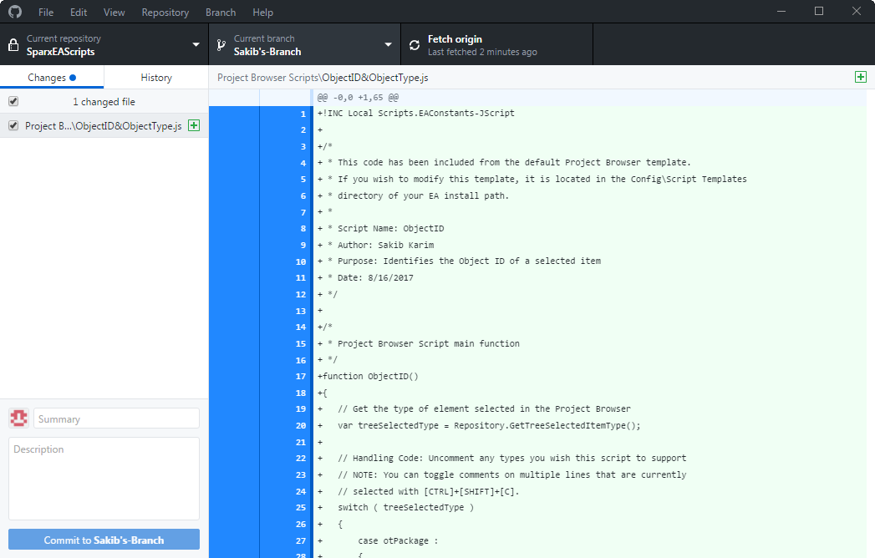After the GitHub Repository folder has been changed, the GitHub desktop application will look like below. The application displays any additions, deletions, and deltas in code.
2. 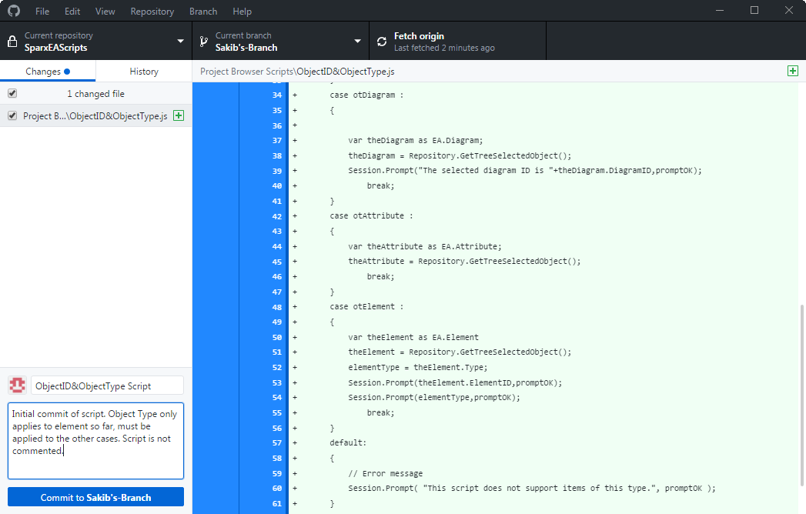After reviewing changes, enter a title for the commit and a short description. Click on the “Commit” button.
3. 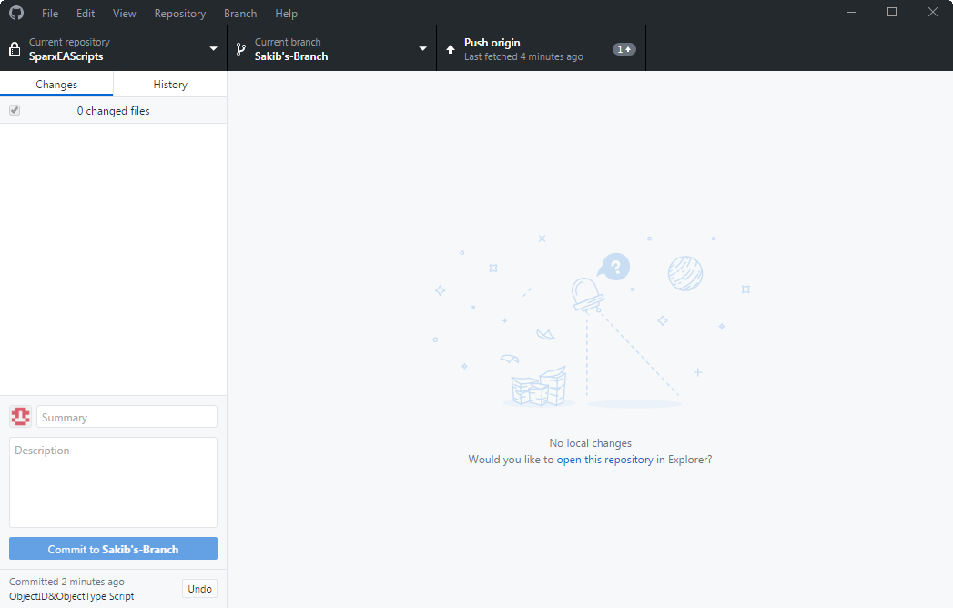The application will update to look similar to below. Click on the “Push origin” button to push the code to the repository.

# GitHub Branches

Branching in GitHub allows the user to create a copy of the “Master” to propose changes by modifying code from the main repository, and then creating a pull request to confirm the changes made. After the pull request is accepted, the proposed changes become a part of the main repository.

1. 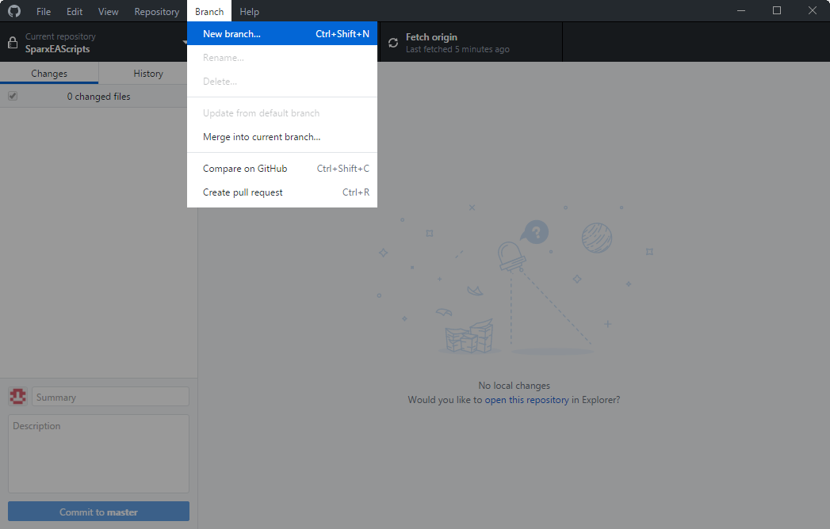To create a branch in the GitHub desktop application, select Branch>New Branch. The
2. 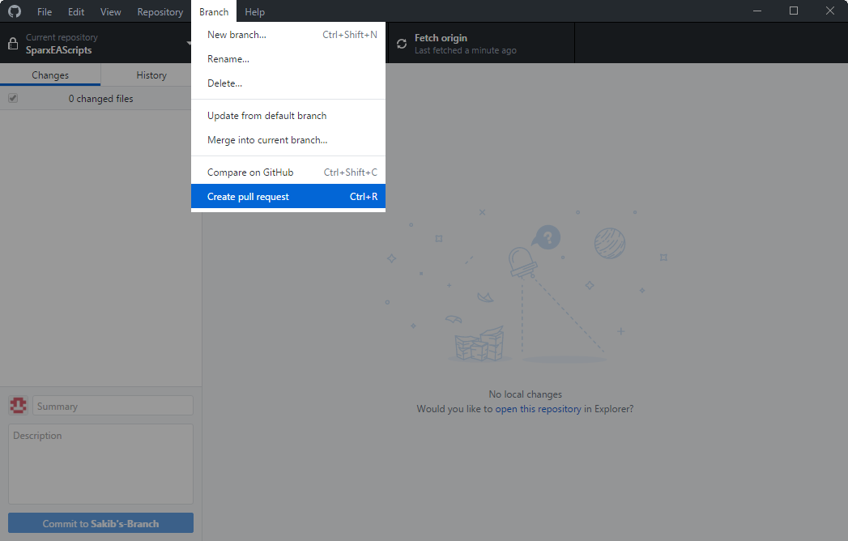For creating “Pull Requests,” select Branch > Create pull request. This will redirect to the online repository to review changes.
3. 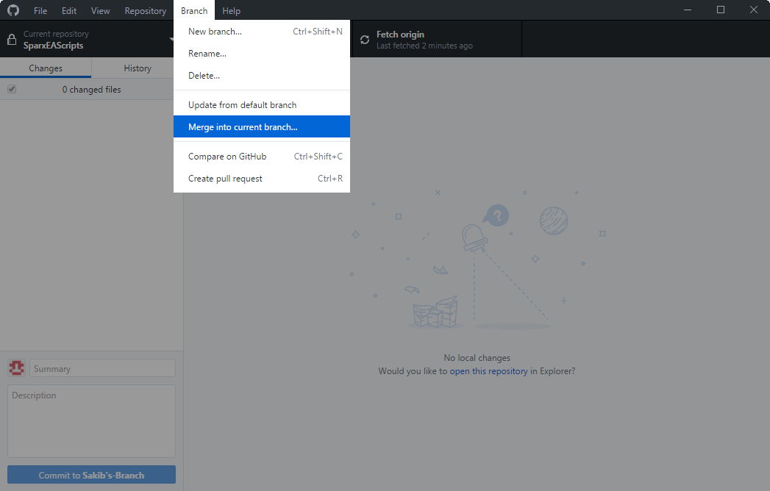After the pull request to reviewed, the branch can be merged into the “Master” branch, implementing changes. Click on Branch > Merge into current branch.
4. A window similar to below will open asking which branch should be merged from.

